Documentary ‘THE CASE FOR HEAVEN’ Answers the Eternal Question About Life After Death

NYT Best-Selling Author Lee Strobel Brings His Latest Work to Movie Theaters Nationwide for a Three-Night Only Event April 4-6

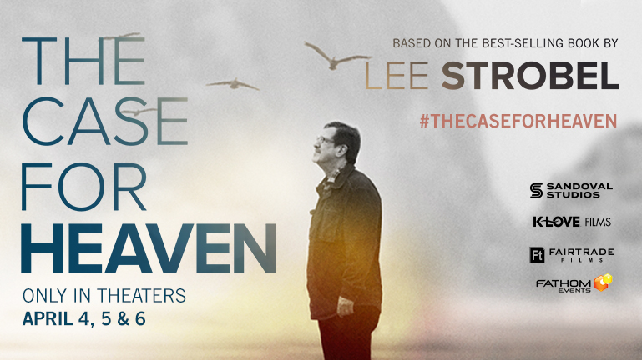

NASHVILLE, Tn. (February 8, 2022) -- Sandoval Studios and K-LOVE Films announce the debut of the new documentary THE CASE FOR HEAVEN, coming to theaters this April for three nights only. Based on the book published by Zondervan Books and written by New York Times best-selling author Lee Strobel, the documentary answers the questions of what awaits us after death, the evidence for Heaven and Hell, and what really happens in Near-Death Experiences.

Watch the trailer for THE CASE FOR HEAVEN here.

Fathom Events and Sandoval Studios have partnered to present this unique event in U.S. cinemas Monday, April 4, Tuesday, April 5, and Wednesday, April 6 at 7:00 p.m. local time (all days).

In THE CASE FOR HEAVEN, director Mani Sandoval takes audiences on a fascinating journey to discover what happens after we die. Lee Strobel explores the evidence for an afterlife as he addresses mankind’s biggest fear: death. THE CASE FOR HEAVEN was inspired by Strobel’s own brush with death and will challenge, encourage and inspire viewers. The documentary includes interviews with world-renowned pastor Francis Chan, best-selling author John Burke, Evangelist Luis Palau, and more.
“The pandemic has a lot of people pondering what happens after people close their eyes for the last time in this world,” said Strobel. “This film provides compelling evidence from both inside and outside the Bible to show that we will, indeed, continue to live on.”
“Heaven, for billions of people around the world, is an awe-inspiring place only fully known once you’re there,” says director Mani Sandoval. “In this film, I believe audiences will experience our most ambitious attempt to sonically, emotionally and cinematically touch Heaven – even if it’s just for a second.”
For more information and to buy your tickets for THE CASE FOR HEAVEN visit www.thecaseforheavenmovie.com.

###

About Fathom Events
Fathom is a recognized leader in the entertainment industry as one of the top distributors of content to movie theaters in North America. Owned by AMC Entertainment Inc. (NYSE: AMC); Cinemark Holdings, Inc. (NYSE: CNK); and Regal Cinemas, a subsidiary of the Cineworld Group (LSE: CINE.L), Fathom operates the largest cinema distribution network, delivering a wide variety of programming and experiences to cinema audiences in all the top U.S. markets and to more than 45 countries. For more information, visit www.FathomEvents.com.

About Sandoval Studios
Sandoval Studios is a rising American film and animation studio, creating standout original content that fuels the spirit, inspires the imagination, and moves the heart. Founded by the Sandoval brothers, the team behind the award-winning Sandoval Agency, Sandoval Studios has a slate of documentaries, feature films and animated series coming soon.

About Educational Media Foundation
EMF began as a single radio station in Northern California in 1982 and is now the parent company to K-LOVE and Air1—the nation’s largest contemporary Christian radio networks. Broadcast on more than 1,000 signals across all 50 states, EMF is also among the top 10 U.S.-based audio streaming companies. In 2019, the ministry acquired WTA Media, a leader in faith-based films and publishing, and oversees its operations in Franklin, Tenn. In 2020, the ministry launched AccessMore, the leading faith-based podcast platform. With more than 400 employees, EMF is headquartered in Rocklin, Calif., and has field team members in major markets throughout the U.S. For more information, visit KLOVE.com, Air1.com, TheWTAgroup.com, or AccessMore.com.

Media Contacts:
Nicole Crumbley
nicole@epic.inc
770-286-1144

Colette Carey
Ccarey@fathomevents.com
720-815-6800

